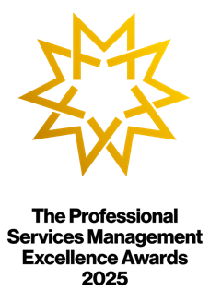

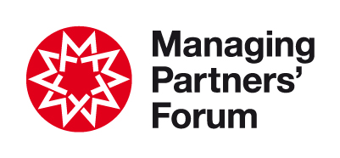
The Professional Services
Management Excellence
Awards 2026

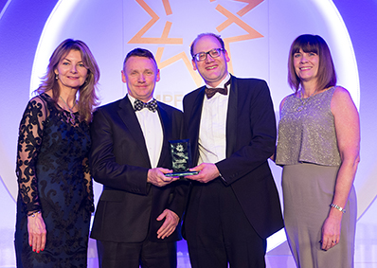
Celebrate leadership & management
These Awards uniquely recognise and celebrate your contribution to the growth of the business - a coherent strategy based on reliable research; a culture capable of adapting to the needs of clients and people; new services; operational efficiency and smart use of technology; investment in brand and marketing; high employee satisfaction levels; and tailored training in ‘soft’ skills.

The focus on management excellence complements UK Government’s ten-year Industrial Strategy which mainly addresses external barriers to growth such as technology adoption, graduate skills, red tape re exports, funding and regulation.

These Awards attract entries from across the world, with over 200 firms entering to date - many on multiple occasions. Forum membership is not essential.

What’s in it for your firm?
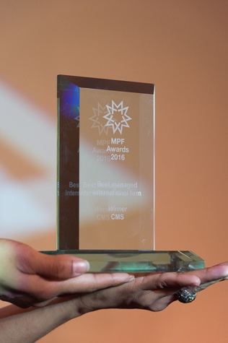
Now in its 23rd year, the Awards provide leaders and management teams with rigorous independent evidence of the impact of their contribution in three key business areas:

• Leadership • Brand • Productivity
Well-managed firms are more productive, according to the Office for National Statistics. Most clients treat the impression of working with a well-managed firm as an essential pre-requisite when instructing an adviser (Source: Managing Partners’ Forum/FT research)

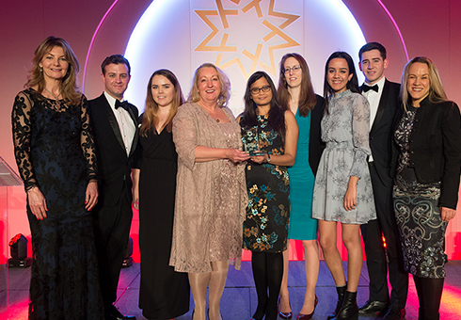
What’s in it for you and your team?
Influencing strategy to enhance business growth and client success is consistently top of the agenda for leaders and management teams. Showing your contribution and impact puts you at the heart of those conversations, increases your influence and strengthens people’s trust in your strategies, while enhancing the reputation of your firm with its clients.
“We are proud of this award which recognises that ideas that offer a competitive business advantage to increasingly sophisticated clients often come from collaboration between professionals.”
Fernando Vives, Executive Chairman, Garrigues

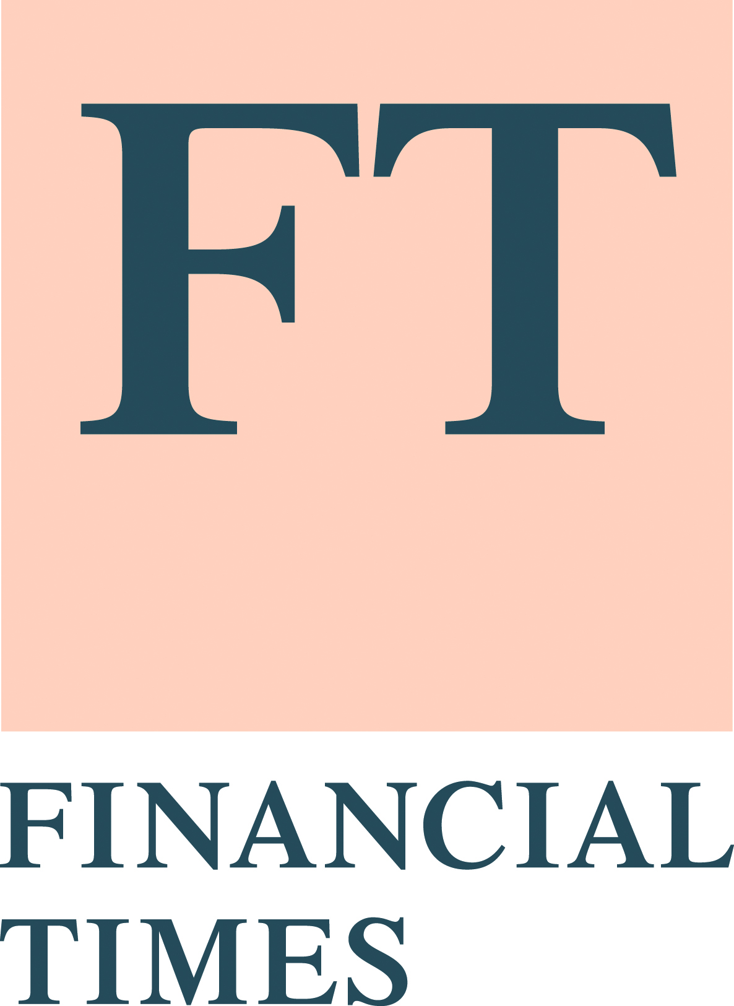
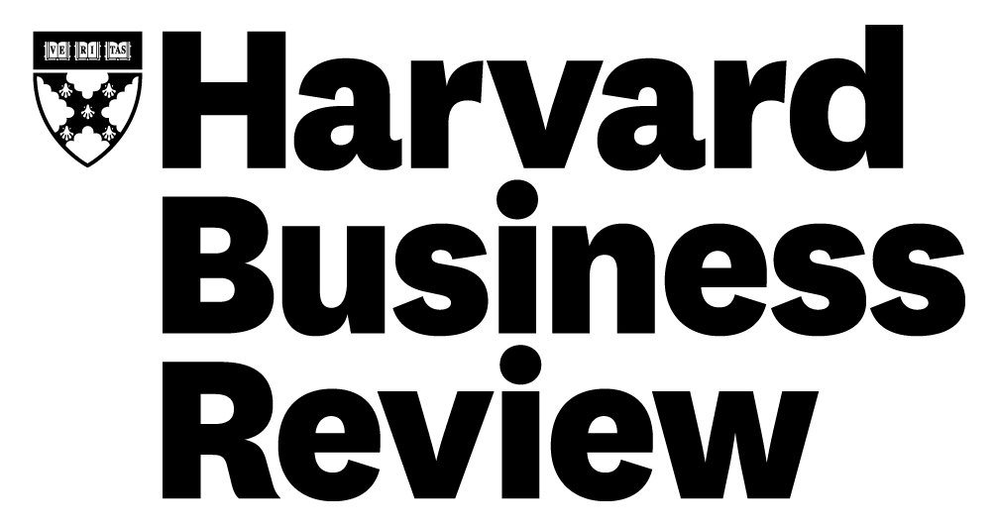
Who else is involved…
In collaboration with longstanding knowledge partners Harvard Business Review and the Financial Times, and leading sponsors, firms of all sizes from across the professions worldwide participate in the Awards – no firm is too big or too small! Management excellence is the key.
“A great opportunity to recognise best practice in the management of professional services. Also an opportunity to acknowledge the important contribution of business services teams. A&L Goodbody is thrilled to have been again recognised in this way.”
Ian White, Director of Strategy & Business Transformation, A&L Goodbody

A night to remember… and ongoing conversations
Over 150 senior attendees come together at the IoD in London for the black-tie gala dinner and Awards ceremony, an integral part of the annual Professional Services Growth Summit.

Hear, at first hand, the progress that has been made by your peers and celebrate your own achievements. Winners will be interviewed live on stage by the MC (Richard Chaplin, host of the popular ‘Retuning your Firm’ show). Questions will not be shared in advance.

Discussions initiated on the night often generate ongoing conversations, inter-firm collaboration, and the forging of strong relationships. To learn more about previous Award winners, please visit the Forum website.
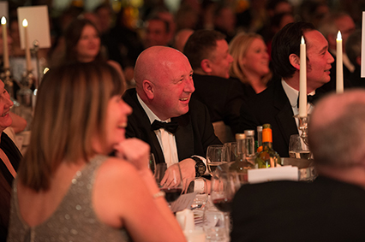
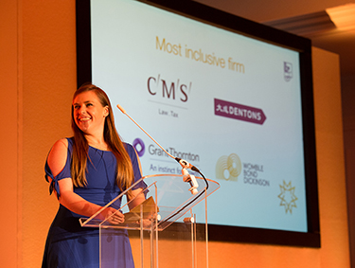

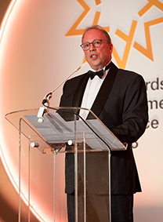
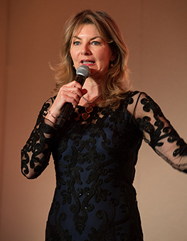
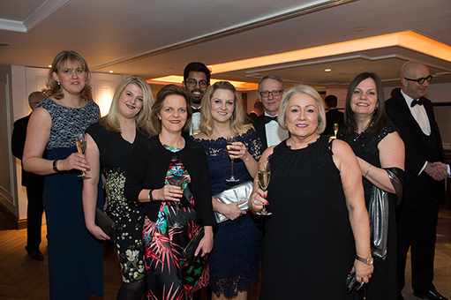

Award categories 2026

Leadership theme:
- Excellence in innovation – For taking innovative ideas and making them repeatable and scalable
- Excellence in social impact – For investing time, money, skills and resources that deliver long term social and economic benefits to local or global communities
- Excellence in strategic leadership – For achieving sustainable superior returns through effective implementation of a coherent strategy

Brand theme:
- Excellence in client service – For enhancing client service in ways that are original and valuable to clients
- Excellence in client solutions – For blazing a trail that contributes to market change
- Excellence in marketing & BD – For creating plans and strategies to market and sell the firm to its target audiences
- Excellence in thought leadership – For distilling and communicating ideas that confer business or consumer advantage and engage target audiences

Productivity theme:
- Excellence in research – For organising ideas and know-how to the benefit of users
- Excellence in skills development – For recognising skills gaps and delivering innovative interventions
- Excellence in technology deployment - For harnessing stacks, systems, tools, frameworks or AI in ways that have a significant positive impact

A fee of £200 + VAT is payable for each submission.

See next pages for:

- The journey to an Award
- Working papers to use when drafting submissions
- Detailed terms and conditions

The journey to an Award

Key dates for the 2026 Awards
- Briefing from the Chair of Judges: XX September 2025
- Open for submissions: 1 October 2025
- Closed for submissions: 31 October 2025
- Shortlists announced: 30 November 2025
- Ceremony: 26 March 2026

Top tips when making a submission
- Evidence of achievement is critical. You must supply tangible ‘proof points’.
- The average time to complete a quality submission is 15 minutes.
- The same initiative cannot be entered for more than one category.
- Reflect on the initiative in the round and over time. Success seldom happens overnight. Provide sufficient detail to allow the judges to grasp the achievement, considering the journey, challenges and milestones.
- Treat it like an elevator pitch - share everything that you are most proud of in a succinct way. Stick to the point and avoid unnecessary information.
- Stay within the word limits. Responses that are significantly below are unlikely to progress; those that significantly above will be penalised.
- Plan ahead and take time to optimise the content before the deadline.

Judging process
Subject matter experts form small panels for each category. Transparent and independent assessment, followed by rigorous discussion and moderation, ensures that all entries are judged objectively on their merits against the assessment criteria. Referees may also be contacted.

Judging criteria
- Strategic alignment
- Active leadership engagement
- Innovation in services, markets, methods or systems
- Effective education of stakeholders
- Positive impact on business growth
- Measurable impact against goals in a reasonable timescale

Ceremony attendance
All entrants will be notified if they have been successful. Places are available for the Ceremony on a first-come first-served basis (minimum two places per shortlisted firm).

Working papers

1. Download a Word version of these working papers from LINK
2 Use the Word version for your drafts as nothing is saved on the online form until the final page.

3 Once approved, paste the final version into the relevant sections of the online form at LINK on or before XXXXXXX 2025.

For each submission, you will be asked:

- Award category
- Firm (name, sector, URL)
- Country
- Entrant details
- Internal referee details
- External referee details
- Leader authorising the entry details

Please ensure that named referees are expecting to be contacted to discuss the initiative on a confidential basis.

- … to provide evidence of achievement and tangible ‘proof points’

- Short title of the initiative. (max 15 words)

This may be used in the Awards programme. It must be different for each entry.

- Brief summary of the initiative. (max 35 words)

This may be used in the Awards programme. It must be different for each entry.

- Challenge or opportunity giving rise to the initiative (max 100 words)

- Start date and key milestones for the initiative (max 50 words)

- Detailed description of the initiative (max 200 words)

… to show how the initiative has involved/ shown:

- Strategic alignment (max 100 words)

- Active leadership engagement (max 100 words)

- Innovation in services, markets, methods or systems (max 100 words)

- Effective education of stakeholders (max 100 words)

... and has resulted in:

- Positive impact on business growth (max 100 words)

- Measurable impact against goals within a reasonable timescale (max 100 words)

Any Additional materials (documents, images, videos, etc) to support the submission must be sent using a file transfer service, with download details sent to Morag Campbell (morag@pmint.co.uk) and sufficient description to enable her to match the additional material to your submission.

Detailed terms & conditions

- The Professional Services Management Excellence Awards 2026 (the Awards) are administered by the experienced team at Practice Management International (PMI). Managing Partners’ Forum is a trading name of PMI.
- PMI reserves the right to publish the names of firms that enter the Awards. You agree a perpetual non-exclusive licence for PMI to publish details of the entry and agree to participate in publicity reasonably requested by PMI. Copyright remains with firms.
- Any inclusion of confidential information is at your sole risk. PMI will make best efforts to keep it confidential but is unable to guarantee that such information will not be published.
- PMI reserves the right to cancel the Awards at any time and to exclude any entries that it considers are inappropriate or do not comply with these conditions. False or deceptive entries will render the firm ineligible from participation in future Awards.
- Shortlisted and winning firms are permitted to use the relevant Awards logo. The use of this logo must be in accordance with applicable PMI branding guidelines in force from time to time. In addition, they must not be used as part of a composite mark or logo, or used in a manner that causes or is likely to cause confusion or a misleading association between the firm/Rising Star and the Forums organised by PMI, or damage to the PMI's goodwill or reputation, or to the validity of any Forum trademark. The right to use the logos may be terminated by PMI at any time.
- PMI accepts no responsibility for, or liability arising from, entrants taking part in the Awards.
- PMI's decisions are final, and no correspondence will be entered into, in particular over the evaluation of entries.
- These conditions are governed by and construed in accordance with English law. Any dispute arising in connection with the Awards shall be subject to the exclusive jurisdiction of the English courts.
- By submitting an entry, you will be deemed to have read, understood and agreed to these conditions on behalf of your firm. You further warrant that you have obtained all necessary consents under applicable data protection and privacy laws to allow the sharing of any personal data contained in the entry with PMI. Any personal data provided will be processed in accordance with PMI's GDPR policy.

