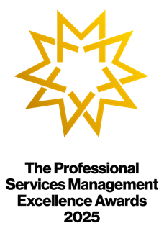

The Professional Services
Management Excellence
Awards 2025

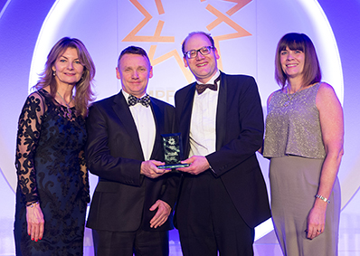
Celebrate your firm’s leadership & management
We operate in an increasingly complex, volatile, and uncertain environment with fast-evolving client expectations. Successful leaders focus on the relationships between 1) profitability; 2) client loyalty; and 3) employee satisfaction, loyalty and productivity. They pay close attention to the needs of their clients and people. They create a culture capable of adapting to the needs of both. These Management Excellence Awards uniquely recognise and celebrate that contribution.

The Awards attract entries from across the world, with over 200 firms entering to date - many on multiple occasions. Forum membership is not essential nor is there a fee for making a submission or nomination.

What’s in it for your firm?
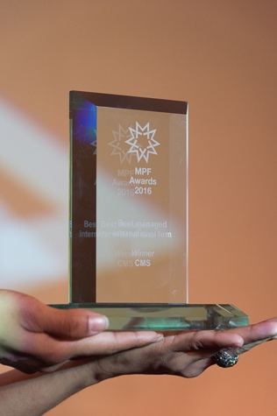
Now in its 22nd year, the Awards provide leaders, management teams (jointly with external consultancies if appropriate) and ‘Rising Stars’ with rigorous independent evidence of the impact of their contribution in four key business areas:

• Leadership & Strategy • Operational Excellence
• Client Focus • Responsible Business
Well-managed firms are more productive, according to the Office for National Statistics. Most clients treat the impression of working with a well-managed firm as an essential pre-requisite when instructing an adviser (Source: Managing Partners’ Forum/FT research)

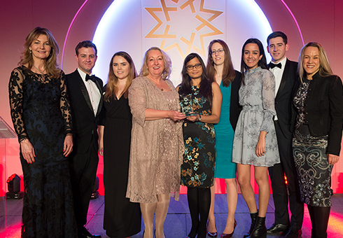
What’s in it for you and your team?
Influencing strategy to enhance business and client success is consistently top of the agenda for leaders, management teams and Rising Stars. Showing your contribution and impact puts you at the heart of those conversations, increases your influence and strengthens people’s trust in your strategies, while enhancing the reputation of your firm with your clients. Teams say what they really think when recognised by their peers.
“We are proud of this award which recognises that ideas that offer a competitive business advantage to increasingly sophisticated clients often come from collaboration between professionals.”
Fernando Vives, Executive Chairman, Garrigues


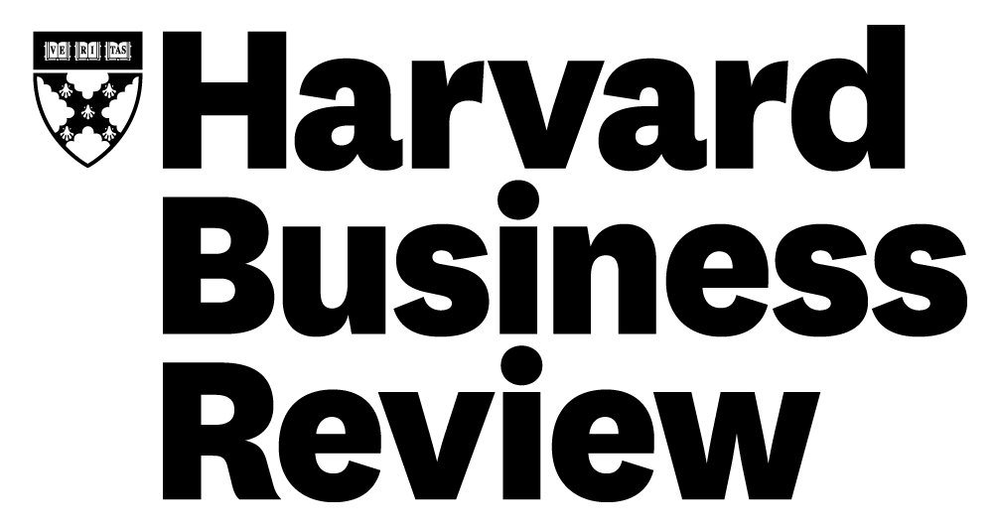
Who else is involved…
In collaboration with longstanding knowledge partners Harvard Business Review and the Financial Times, and leading sponsors, firms of all sizes from across the professions worldwide participate in the Awards – no firm is too big or too small! Management excellence is the key.
“A great opportunity to recognise best practice in the management of professional services. Also an opportunity to acknowledge the important contribution of business services teams. A&L Goodbody is thrilled to have been again recognised in this way.”
Ian White, Director of Strategy & Business Transformation, A&L Goodbody

A night to remember… and ongoing conversations
Over 300 senior attendees and a celebrity guest speaker come together at the gala dinner and Awards ceremony in London on the evening of Wednesday 26 March 2025. In addition to the open categories, the Forum presents a merit award for exceptional achievement. Hear, at first hand, the progress that has been made by your peers and celebrate your own achievements. Discussions initiated on the night often generate ongoing conversations, inter-firm collaboration, and the forging of strong relationships. Winners are invited to join a private online group for winners on the Forum’s Skills Development Platform, and to attend the Award winners’ dinner in June 2025.

To learn more about previous Award winners, please visit the Forum website.

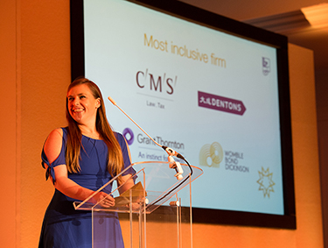

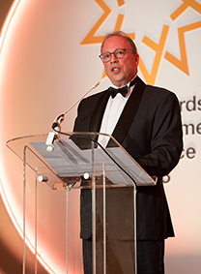

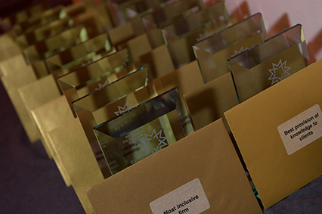



Categories 2025
All categories are eligible for ‘Rising Star’ submissions

Leadership & Strategy
- Excellence in Firmwide Leadership: For achieving sustainable superior returns through effective implementation of a coherent strategy
- Excellence in Divisional Leadership: For achieving sustainable superior returns through effective implementation of a coherent strategy
- Excellence in Leadership Development: For recognising skills gaps and delivering innovative interventions
- Excellence in Performance Management: For implementing transparent systems that track progress against personal goals and assess team contribution.

Client Focus
- Excellence in Client Service: For enhancing client service in ways that are original and valuable to clients
- Excellence in Client Solutions: For blazing a trail that contributes to market change
- Excellence in Marketing and Business Development: For creating plans and strategies to market and sell the firm to its target audiences
- Excellence in Thought Leadership: For distilling and communicating ideas that confer business or consumer advantage and engage target audiences

Operational Excellence
- Excellence in Financial and Risk Management: For involving everyone in the delivery of optimal financial performance and/or for creating a risk framework to monitor compliance and changing scenarios
- Excellence in People Management: For fostering collaborative working, well-being, productivity and client engagement
- Excellence in Knowledge Management: For organising know-how to the benefit of users
- Excellence in Technology Deployment: For harnessing stacks, systems, tools, frameworks or AI in ways that have a significant positive impact
- Excellence in Working Environment: For organising office layout and facilities that complement remote working

Responsible Business
- Excellence in Community Engagement: For investing time, money, skills and resources that deliver long term social and economic benefits to local communities
- Excellence in Inclusiveness: For creating an environment where anyone can feel comfortable and has the opportunity to shine
- Excellence in Social Mobility: For sourcing talent from a wide range of backgrounds

The journey to an Award

Nominations
Anyone can nominate a leader, management team or Rising Star. Rising Stars show exceptional performance, are leaders among their peers and exceed expectations ‐ the ones to watch. They must also be aged 35 or under at the submission deadline (40 for leadership & strategy categories).

On receiving a nomination (must be online), the Forum contacts the appropriate person: leaders/management teams must self-enter; Rising Stars can either self-submit or be entered by someone else (for example their team leader) with or without their knowledge. If shortlisted for an online interview, they can then decide whether to participate.

Top tips when making a submission
- Evidence of achievement is critical. You must supply tangible ‘proof points’.
- The average time to complete a quality submission is 15 minutes.
- The same initiative or Rising Star cannot be entered for more than one category.
- Reflect on the initiative or the Rising Star in the round and over time. Success seldom happens overnight. Provide sufficient detail to allow the judges to grasp their achievement, considering the journey, challenges and milestones.
- Treat it like an elevator pitch - share everything that you are most proud of in a succinct way. Stick to the point and avoid unnecessary information.
- Stay within the word limits. Responses that are significantly below are unlikely to progress; those that significantly above will be penalised.
- Plan ahead and take time to optimise the content before the deadline.
Judging process
Subject matter experts form small panels for each category. Transparent and independent assessment, followed by rigorous discussion and moderation, ensures that all entries are judged objectively on their merits against the assessment criteria. Referees may also be contacted.

Judging criteria for management team initiatives
- Strategic alignment
- Active leadership engagement
- Innovation in services, markets, methods or systems
- Effective education of stakeholders
- Positive impact on the client experience, employee engagement or stakeholder performance
- Measurable impact against goals in a reasonable timescale

Judging criteria for rising stars
- Impressive metrics – targets, percentage increases/decreases, retention statistics.
- Examples of dynamism and daring to be different or challenging the status quo.
- Cutting-edge inventions, process improvements or digital innovations.
- Technical or creative excellence that has been recognised internally and/or externally.
- Evidence that others are significantly inspired by the Rising Star.
- Achieving success beyond immediate business objectives, expectations or targets.
Ceremony attendance
All entrants will be notified in due course if they have been successful. They must be available for the Ceremony on the evening of 26 March 2025 in London.
Working papers

Use the following pages for drafts as nothing is saved until the final page. Once approved, paste the final version into the relevant sections of the online form.

For each entry, you will be asked:

- The Award Category

- The firm – name, sector, URL, footprint, local headcount, local revenues

- Any consultancies that made a vital contribution to the initiative (for joint recognition)

- The country of the initiative/ Rising Star
- Key contacts – Entrant | Internal referee | External referee | Leader who has authorised the entry (name, job title, organisation, city, phone, email)
Please ensure that named referees are expecting to be contacted to discuss the initiative/Rising Star on a confidential basis.

- … to provide evidence of achievement and tangible ‘proof points’

- Short title of the leadership/management team initiative
Name of the Rising Star (max 15 words)
This may be used in the Awards programme. It must be different for each entry.

- Brief summary of the initiative
Brief summary of the exceptional performance (max 35 words)
This may be used in the Awards programme. It must be different for each entry.

- Challenge or opportunity giving rise to the initiative
Challenge or opportunity giving rise to the exceptional performance (max 100 words)

- Start date and key milestones for the initiative
Start date and key milestones for the exceptional performance (max 50 words)

- Detailed description of the initiative
Detailed description of the exceptional performance (max 200 words)

… to show how the initiative/ Rising Star has involved/ shown:

- Strategic alignment
Impressive metrics (max 100 words)

- Active leadership engagement
Challenge to the status quo (max 100 words)

- Innovation in services, markets, methods or systems
Inventions, improvements and innovation (max 100 words)

- Effective education of stakeholders
Technical or creative excellence (max 100 words)

... and has resulted in:

- Positive impact on the client experience, employee engagement or stakeholder performance
Others being significantly inspired (max 100 words)

- Measurable impact against goals within a reasonable timescale
Success beyond immediate objectives and targets (max 100 words)

Any Additional materials (documents, images, videos, etc) to support the entry must be sent to PMI. Please use a file transfer service with download details sent to Morag Campbell (morag@pmint.co.uk) and sufficient description to enable her to match the additional material to your entry.

Detailed terms & conditions

- Practice Management International LLP (PMI) reserves the right to publish the names of firms/Rising Stars that enter The Professional Services Management Excellence Awards (the Awards). You agree a perpetual non-exclusive licence for PMI to publish details of the entry and agree to participate in publicity reasonably requested by PMI. Copyright remains with firms/Rising Stars.
- Any inclusion of confidential information is at your sole risk. PMI will make best efforts to keep it confidential but is unable to guarantee that such information will not be published.
- PMI reserves the right to cancel the Awards at any time and to exclude any entries that it considers are inappropriate or do not comply with these conditions. False or deceptive entries will render the firm/Rising Star ineligible from participation in future Awards.
- Shortlisted and winning firms/Rising Stars are permitted to use the relevant Awards logo. The use of this logo must be in accordance with applicable PMI branding guidelines in force from time to time. In addition, they must not be used as part of a composite mark or logo, or used in a manner that causes or is likely to cause confusion or a misleading association between the firm/Rising Star and the Forums organised by PMI, or damage to the PMI's goodwill or reputation, or to the validity of any Forum trademark. The right to use the logos may be terminated by PMI at any time.
- PMI accepts no responsibility for, or liability arising from, entrants taking part in the Awards.
- PMI's decisions are final, and no correspondence will be entered into, in particular over the evaluation of entries.
- These conditions are governed by and construed in accordance with English law. Any dispute arising in connection with the Awards shall be subject to the exclusive jurisdiction of the English courts.
- By submitting an entry, you will be deemed to have read, understood and agreed to these conditions on behalf of your firm. You further warrant that you have obtained all necessary consents under applicable data protection and privacy laws to allow the sharing of any personal data contained in the entry with PMI. Any personal data provided will be processed in accordance with PMI's GDPR policy.

